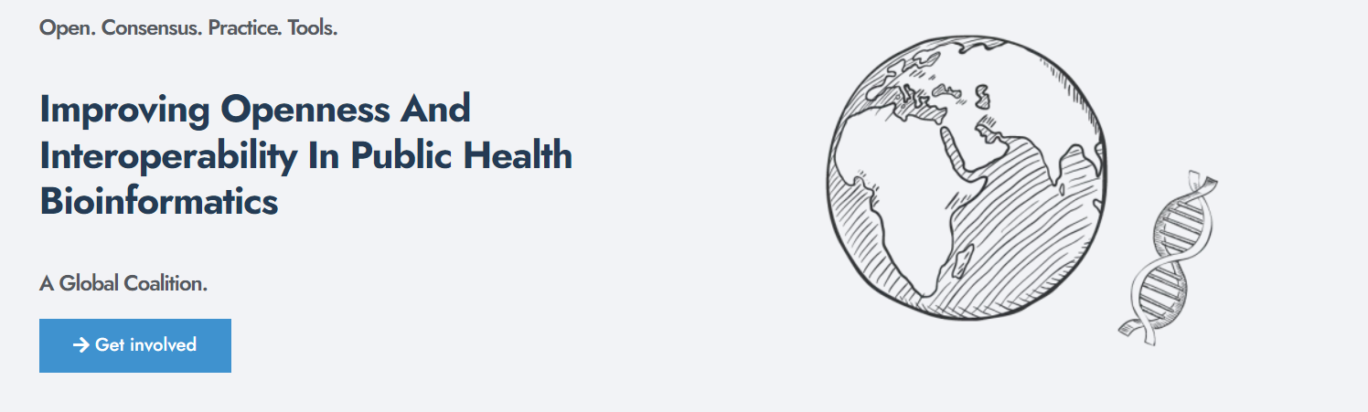

Designed by Charlie Barclay, Emma Griffiths and Rhiannon Cameron as part of PHA4GECon 2025 pre-conference workshops

PHA4GECon 2025: Scoping

*Defining your audience, data need and setting boundaries*

This template is designed to guide defining the purpose and rationale for a new standard by systematically evaluating the requirements and stakeholder need, ensuring the new standard addresses genuine gaps and has a clear well-defined scope.

# Scope

## 1.1: Problem Statement

What specific problem or gap will this standard address?

Why is a new/adapted standard/module necessary?

## 1.2 Requirement for a new standard

Are there any existing standards for this domain?

Summarise the gaps/lack of applicability to this use case

## 1.3 Defining the boundaries:

What are the in-scope elements (data domains, use cases)?

What are the out-of-scope elements?

Who is the intended audience/end users?

# Stakeholders and Audience

## 2.1 Define the key stakeholders

List key groups involved or affected and how each uses or contributes data.

# Preliminary Standards Review

## 3.1 Existing Standards

List the existing standards, NCBI and ENA, MiXS, PHA4GE

## 3.2 Identify common data elements

What common data fields are across these standards

## 3.3 Missing data elements